MYSQL ASSIGNMENT 2 -
CLAUSES AND JOINS

BY
ATHIRA SASEENDRAN

INTRODUCTION
MySQL is a widely used relational database management system that allows users to store, manage, and retrieve data efficiently. This assignment focuses on performing various SQL operations using MySQL Workbench on an employee database. The tasks include retrieving distinct values, filtering and sorting data, using aggregate functions, grouping records, applying conditions with HAVING, and working with different types of joins such as INNER JOIN, LEFT JOIN, and RIGHT JOIN. Through these exercises, the assignment provides practical understanding of how SQL queries can be used to manage and analyse relational data.

Populating the database using the provided Employee Data DML statements
This assignment was continued from the previous assignment, where the database, tables, and required constraints were created. The provided Employee Data DML insert statements were then used to populate the tables with the required department, location, and employee records. After inserting the data, the SQL queries given in this assignment were executed on the populated database.

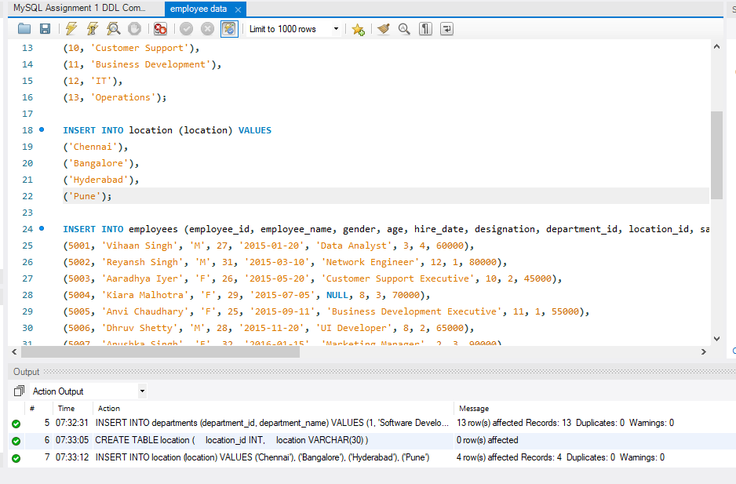

- DISTINCT VALUES
To retrieve the distinct salary values from the employees table.

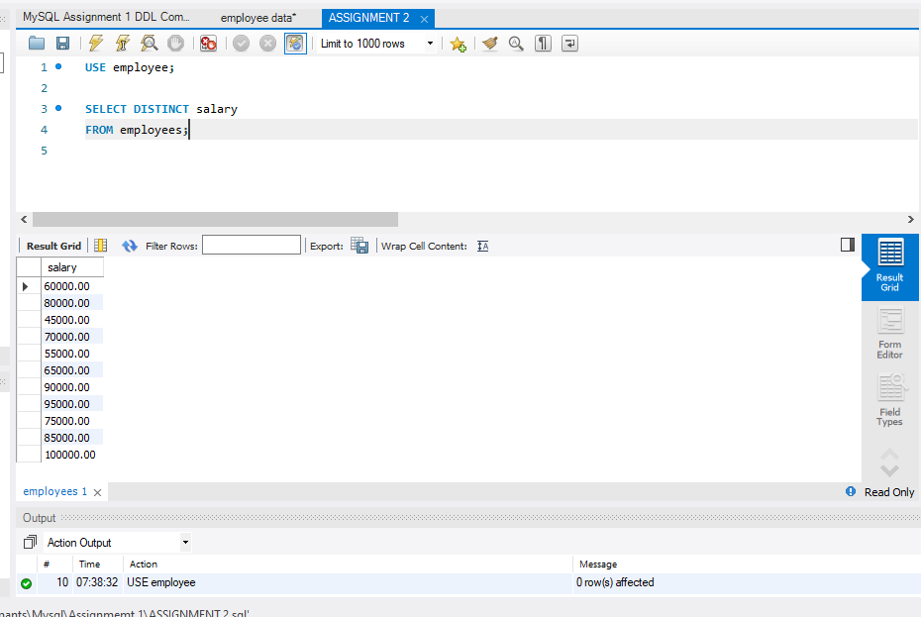

- ALIAS (AS)
To display the age and salary columns using the specified aliases.
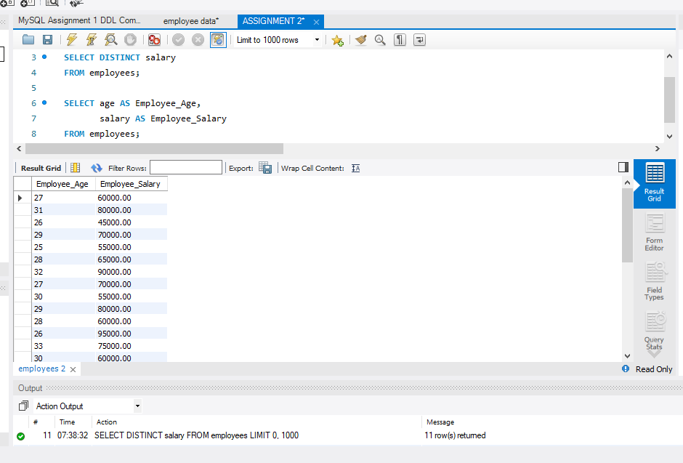

- WHERE CLAUSE & OPERATORS

- To retrieve employees whose salary is greater than ₹50,000 and who were hired before 1 January 2016.
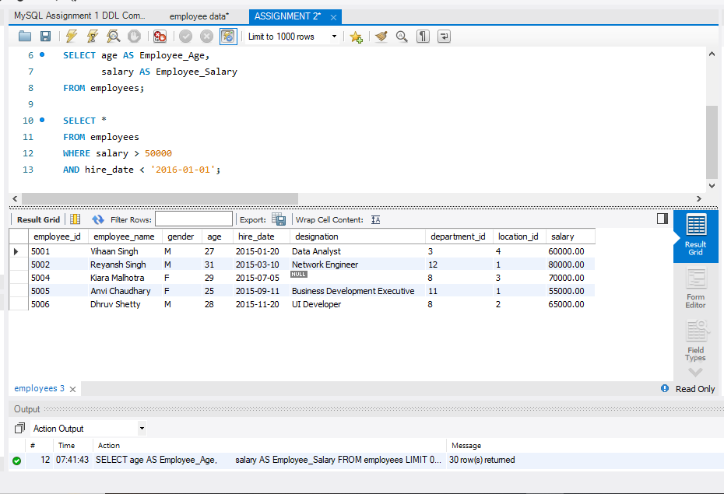

- To identify the employee whose designation is missing. IS NULL is used to find records where the designation value is missing.
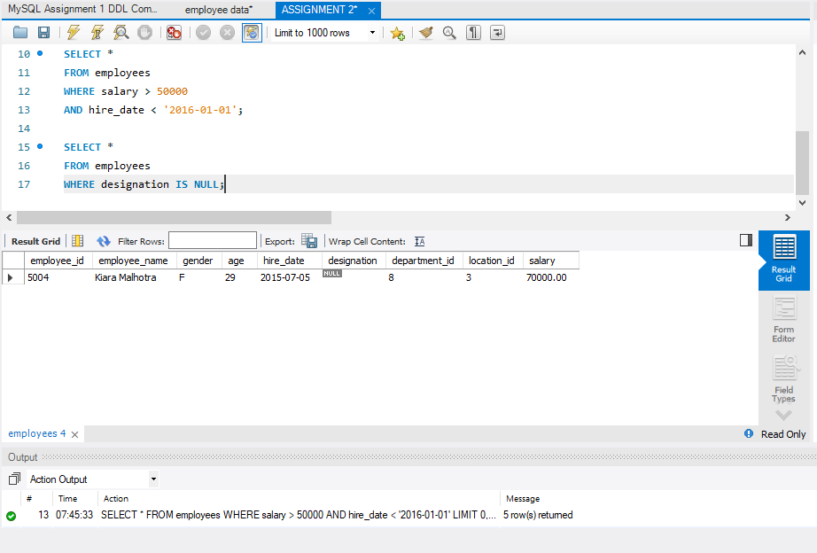

The UPDATE statement changes the missing designation of employee 5004 to Data Scientist.
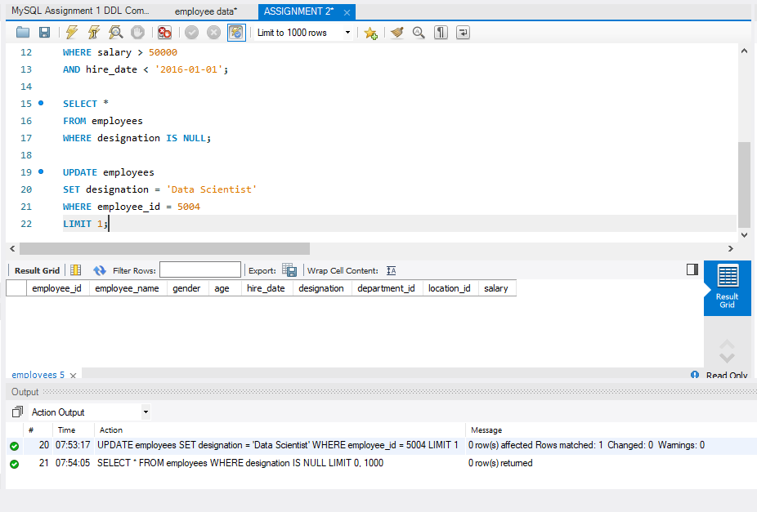

SORTING AND GROUPING DATA
- ORDER BY
To sort employees by department ID and salary…
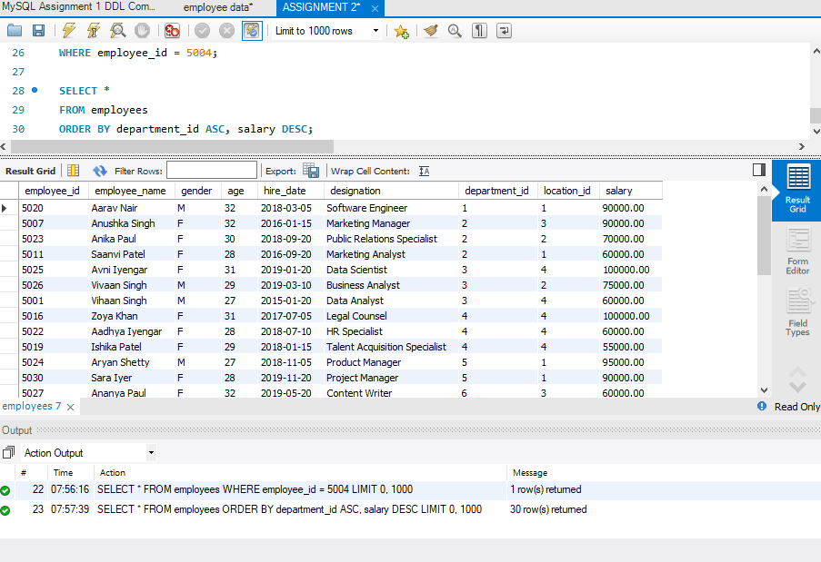

- LIMIT
Displaying the first five employees hired in 2018
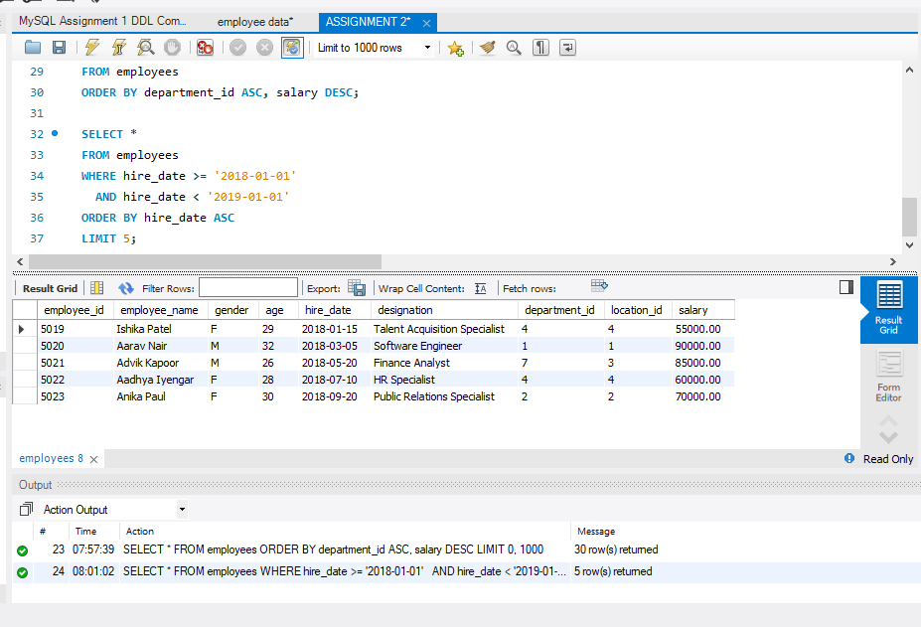

- AGGREGATE FUNCTIONS

a). Calculating the total salary of the Finance department. Using SUM()
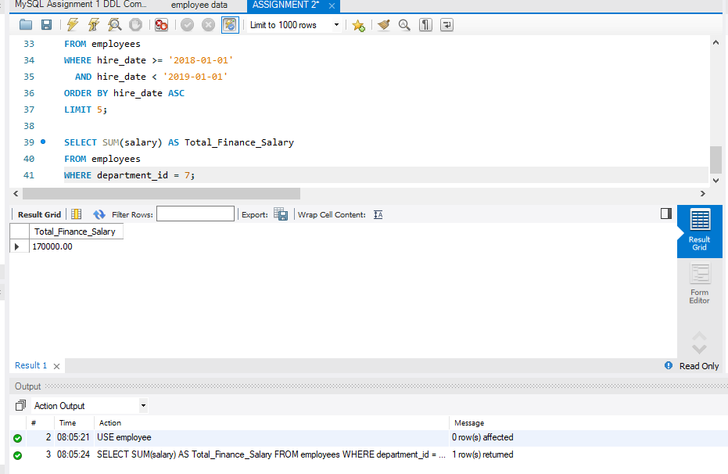

b). Finding the minimum age among employees. Using MIN().
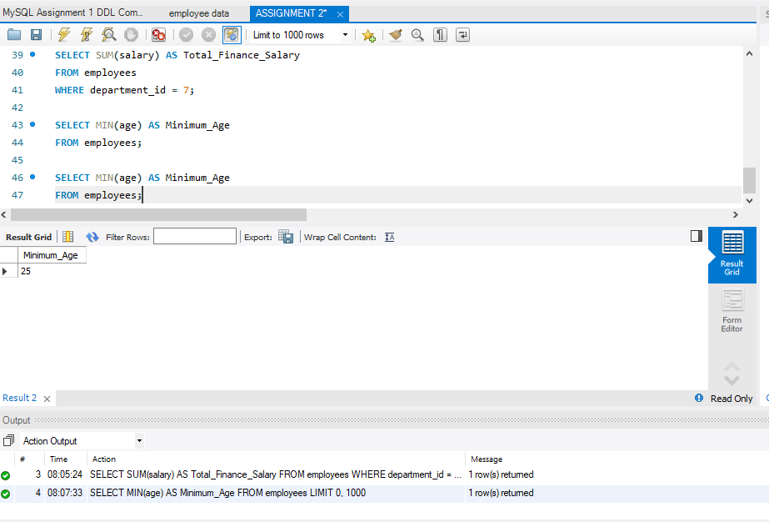

- GROUP BY
a). Finding the maximum salary for each location
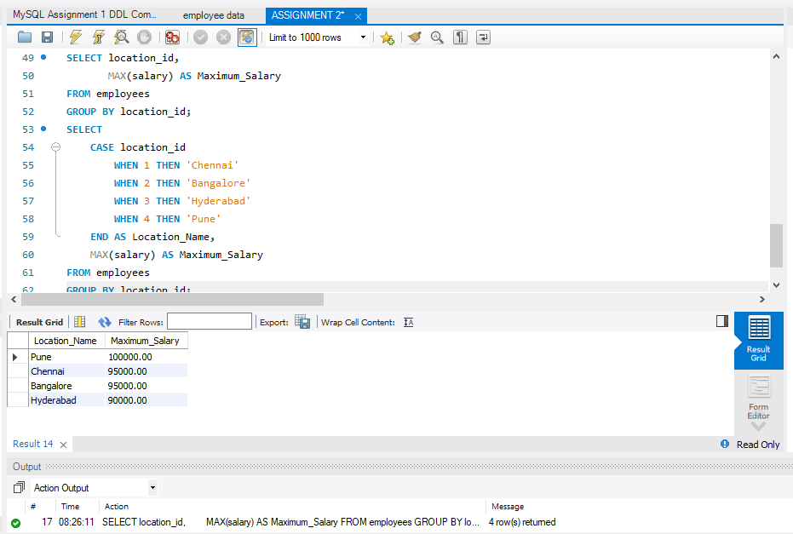

b). Calculating average salary for Analyst designations.
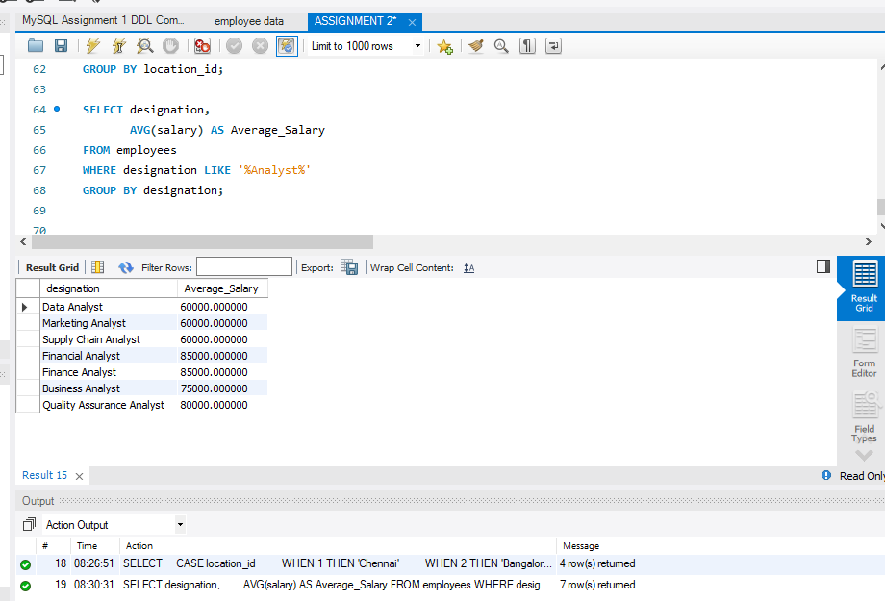

- HAVING
a). Finding departments with fewer than three employees

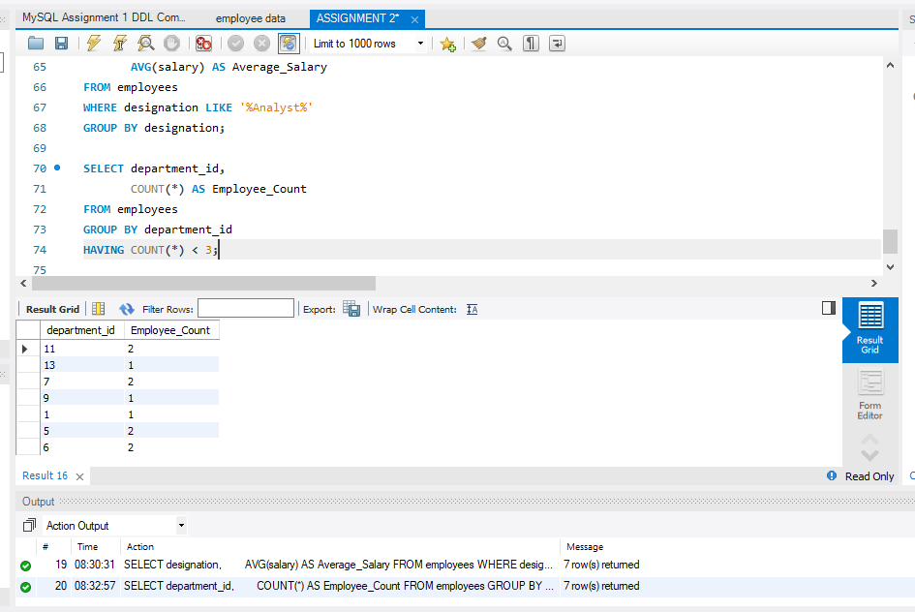

b). Finding locations with female employees whose average age is below 30.

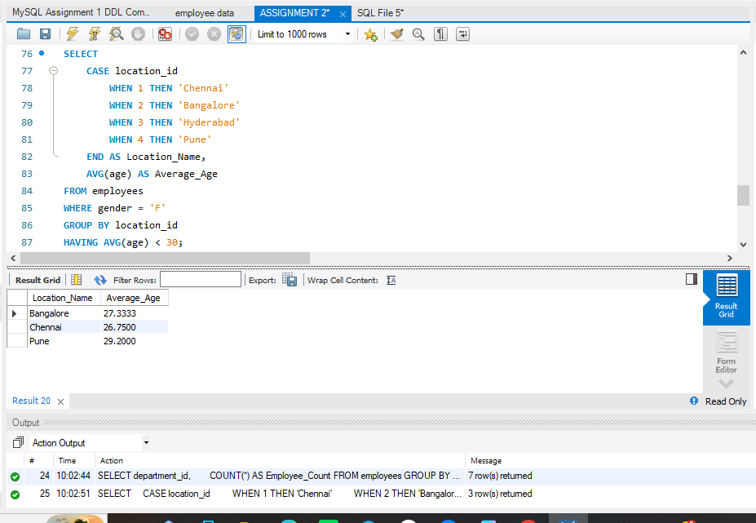

JOINS
- INNER JOIN
Using INNER JOIN to display employee and department details

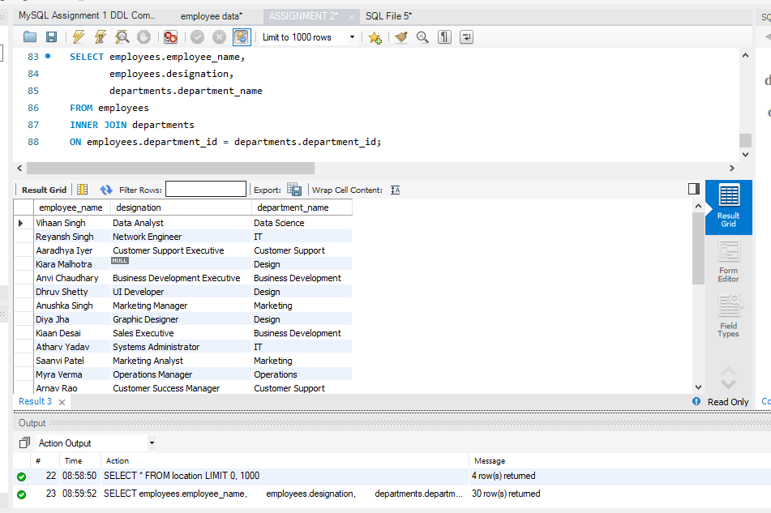

- LEFT JOIN
Listing all departments with their employee counts using LEFT JOIN

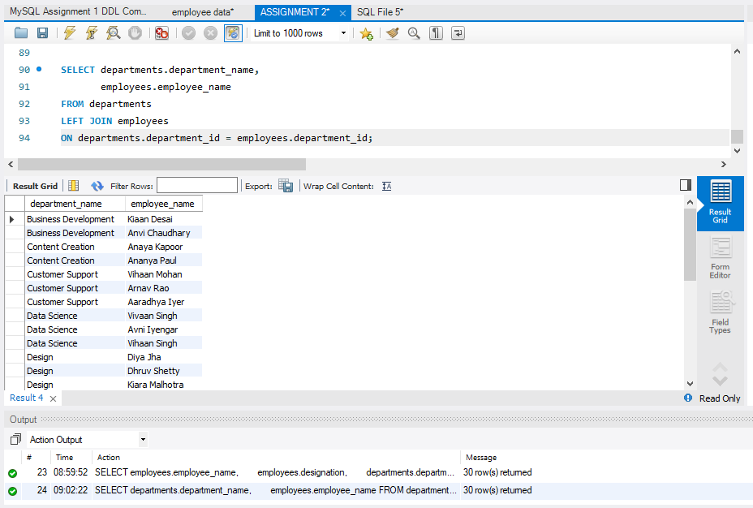

- RIGHT JOIN
Using RIGHT JOIN to display locations and assigned employees

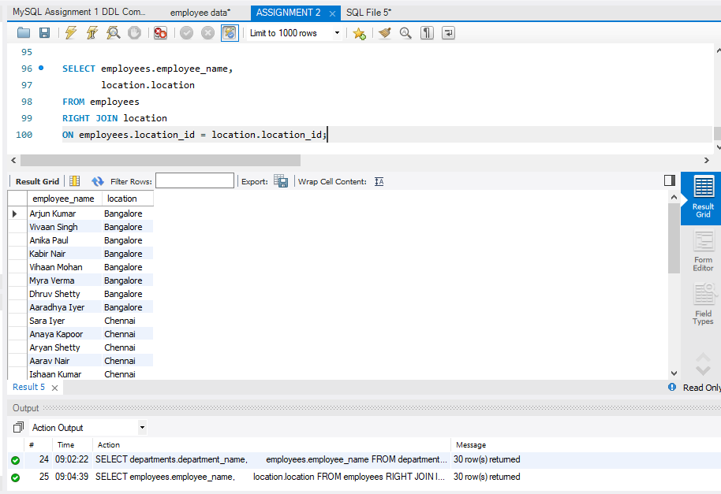

CONCLUSION
This assignment provided practical experience in working with MySQL and SQL queries using an employee database. Through the different exercises, I learned how to retrieve distinct values, filter and sort records, use aggregate functions, group data, and apply conditions using HAVING. The assignment also helped me understand how INNER JOIN, LEFT JOIN, and RIGHT JOIN can be used to retrieve related information from different tables. Overall, the practical exercises improved my understanding of SQL and strengthened my ability to work with relational databases using MySQL Workbench.

